Install Linux in a Virtual Machine & Explore the GUI

# Objectives

Part 1: Prepare a Computer for Virtualization

Part 2: Install a Linux OS on the Virtual Machine

Part 3: Explore the GUI

# Background / Scenario

Computing power and resources have increased tremendously over the last 10 years. A benefit of multi-core processors and large amounts of RAM is the ability to install multiple operating systems through the use of virtualization on a computer.

With virtualization, one or more virtual computers can operate inside one physical computer. Virtual computers that run within physical computers are called virtual machines. Virtual machines are often called guests, and physical computers are often called hosts. Anyone with a modern computer and operating system can run virtual machines.

In this lab, you will install a Linux OS in a virtual machine using a desktop virtualization application, such as VirtualBox. After completing the installation, you will explore the GUI interface. You will also explore the command line interface using this virtual machine in a lab later in this course.

# Required Resources

* Computer with a minimum of 2 GB of RAM and 10 GB of free disk space
* High-speed Internet access to download Oracle VirtualBox and Linux OS image, such as Ubuntu Desktop

# Instructions

## Prepare a Computer for Virtualization

In Part 1, you will download and install desktop virtualization software and a Linux OS image. Your instructor may provide you with a Linux OS image.

### Download and install VirtualBox.

VMware Player and Oracle VirtualBox are two virtualization programs that you can download and install to support the OS image file. In this lab, you will use the VirtualBox application.

* + - 1. Navigate to <https://www.virtualbox.org/>. Click the download link on this page.
      2. Choose and download the appropriate installation file based on your operating system.
      3. After the VirtualBox installation file is downloaded, run the installer and accept the default installation settings.

### Download a Linux Image.

* + - 1. Navigate to the Ubuntu website at <http://www.ubuntu.com>. Click the Download link on this page to download and save an Ubuntu Desktop image.

### Create a New Virtual Machine.

* + - 1. Click **Start** and search for **Virtualbox**. Click **Oracle VM VirtualBox** to open the manager. When the manager opens, click **New** to start the Ubuntu installation.
      2. In the **Name and operating system** screen, type **Ubuntu** in the **Name** field. For the **Type** field, select **Linux**. In the **Version** field, select the corresponding downloaded version. Click **Next** to continue.
      3. In the **Memory size** screen, increase the amount of RAM as long as the amount of RAM for the virtual machine is in the green area. Going beyond the green area would adversely affect the performance of the host. Click **Next** to continue.
      4. In the **Hard disk** screen, click **Create** to create a virtual hard disk now.
      5. In the **Hard disk file type** screen, use the default file type settings of **VDI (VirtualBox Disk Image)**. Click **Next** to continue.
      6. In the **Storage on physical hard disk** screen, use the default storage settings of **dynamically allocated**. Click **Next** to continue.
      7. In the **File location and size** screen, you can adjust the hard drive and change the name and location of the virtual hard drive. Click **Create** to use the default settings.
      8. When the hard drive creation is done, the new virtual machine is listed in the **Oracle VM VirtualBox Manager** window. Select **Ubuntu** and click **Start** in the top menu.

## Install Ubuntu on the virtual machine

### Mount the Image.

* + - 1. In the **Oracle VM Virtualbox Manager** window. Right-click **Ubuntu** and select **Settings**. In the **Ubuntu – Settings** window, click **Storage** in the left pane. Click **Empty** in the middle pane. In the right pane, click the CD symbol and select the file location of the Ubuntu image. Click **OK** to continue.
      2. In the **Oracle VM VirtualBox Manager** window, click **Start** in the top menu.

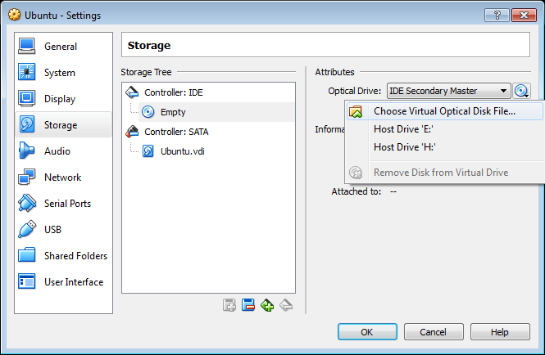

### Install the OS.

* + - 1. In the **Welcome** screen, you are prompted to try or install Ubuntu. The try option does not install the OS, it runs the OS straight from the image. In this lab, you will install the Ubuntu OS in this virtual machine. Click **Install Ubuntu**.
      2. Follow the on-screen instructions and provide the necessary information when prompted.

**Note**: If you are not connected to the Internet, you can continue to install and enable the network later.

* + - 1. Because this Ubuntu installation is in a virtual machine, it is safe to erase the disk and install Ubuntu without affecting the host computer. Select **Erase disk and install Ubuntu**. Otherwise installing Ubuntu on a physical computer would erase all data on the disk and replace the existing operating system with Ubuntu. Click **Install Now** to start the installation.
      2. Click **Continue** to erase the disk and install Ubuntu.
      3. In the **Who are you?** screen, provide your name and choose a password. Use **iteuser** for **Your Name** and **ITEpass!** for the password. You can use the username generated or enter a different username. If desired, you can change the other settings. Click **Continue**.
      4. The Ubuntu OS is now installing in the virtual machine. This will take several minutes. When the **Installation is complete** message displays, return to the **Oracle VM Virtualbox Manager** window. Right-click **Ubuntu** and select **Settings**. In the **Ubuntu – Settings** window, click **Storage** in the left pane. Click the mounted Ubuntu image in the middle pane. In the right pane, click the CD symbol and click **Remove Disk from Virtual Drive**. Click **OK** to continue.
      5. In the Ubuntu VM, click **Restart Now**.

## Explore the GUI

In this part, you will install the VirtualBox guest additions and explore the Ubuntu GUI.

### Install Guest Additions.

* + - 1. Log on to your Ubuntu virtual machine using the user credentials created in the previous part.
      2. Your Ubuntu Desktop window may be smaller than expected. This is especially true on high-resolution displays. Click **Device > Insert Guest Additions CD image…** to install the Guest Additions. This allows more functions, such as changing the screen resolution in the virtual machine.

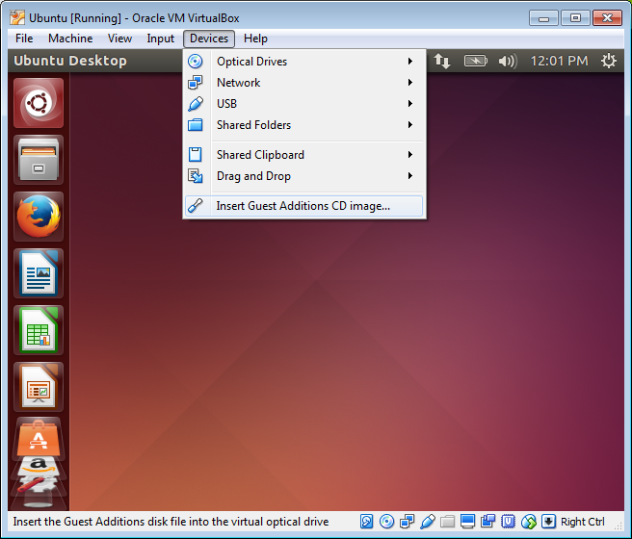

* + - 1. Click **Run** to install the additions. When prompted for a password, use the same password that you used to log on. Click **Authenticate** to continue.
      2. If the computer was not connected to the Internet during the installation, click **Devices > Network Settings** in the Oracle VirtualBox menu. Enable network adapters and configure the proper setting for network connections as necessary. Click **OK**.
      3. When the installation of the additions is done, restart the virtual machine again. Click the menu in the upper-right corner and click **Shut down**. Click **Restart** to restart Ubuntu.

### Open a web browser.

* + - 1. Log on to Ubuntu again. After you are logged on again, you can resize the virtual machine window.
      2. Open a web browser. Depending on the Linux distribution, you may need to search for a web browser or there is a link to a web browser already on the Desktop.
      3. Locate a terminal emulator to access the command line interface. You will be using a terminal emulator in later labs.
      4. Explore the installed Linux distribution and locate a few applications that you may use.

End of Document